March Madness Model Theory
Contributors: Neal Anderson
Last Edited 3/31/2015

NCAA Men’s Basketball Tournament
The NCAA Men’s Basketball Tournament is a 64-team single elimination tournament. The Tournament is divided into 6 rounds. In each round, each eligible team plays one game against another eligible team. The matchups are determined by a single elimination bracket structure. The winner of each game advances to the next round and the loser is eliminated from the tournament. There are 64 teams in the first round, 32,16,8,4,2 in the following rounds, respectively. The games (of which there are 63) continue until an undefeated champion is crowned.

NCAA Tournament Bracket Challenge
In the NCAA Tournament Bracket Challenge, a contestant fills out a bracket detailing how he or she believes the tournament will unfold, i.e. he or she specifies the winners of each of the 63 games. Allowable winners of a game must be able to advance to the given game per the tournament bracket. Allowable winners of a game must also be chosen to advance through all previous rounds to be chosen in a given current round. Score in the Bracket Challenge is determined by adding up the points received from correct predictions in each of the 63 games of the tournament. Each game is given a specific number of points, which one can earn by predicting the team correctly that advances to a given game of a tournament. Typically, 1 round is awarded for 1st round predictions, 2 points for 2nd round predictions, 4 for 3rd round preditions, 8 for 4th round predictions, 16 for 5th round predictions, and 32 for a correct champion. The winner of the bracket challenge is one who scores the most points at the end of the tournament.

NCAA Tournament Pool Structure
Often participants in the Bracket Challenge self organize into “pools” in which each entrant pays an entry fee, and at the end of the tournament the entrant with the most points takes home all the money in the pool.

March Madness Model

Goal:
Increase one’s chance of winning by maximizing “expected relative score”;

States:
Each Game in the Tournament (states 1-63) + one absorbing state (state 64).
Bracket-State Map:
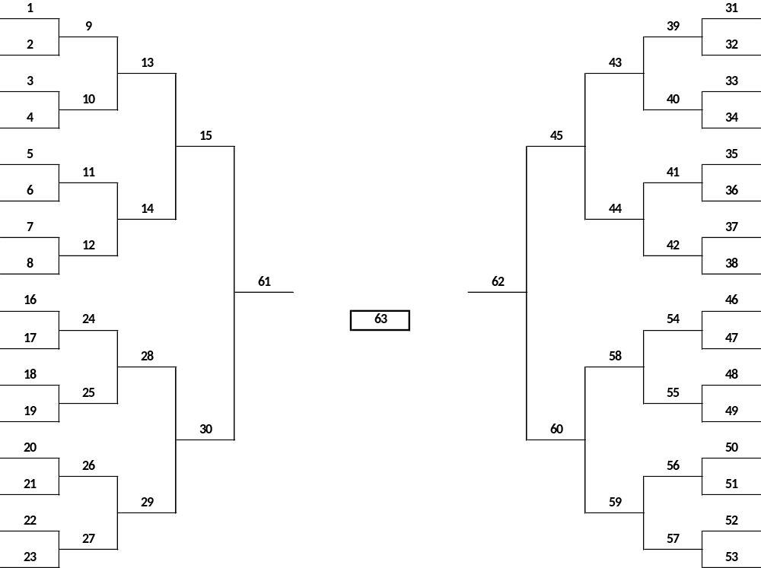

Actions:
Each Action represents picking one of the 64 teams to win the current game state.
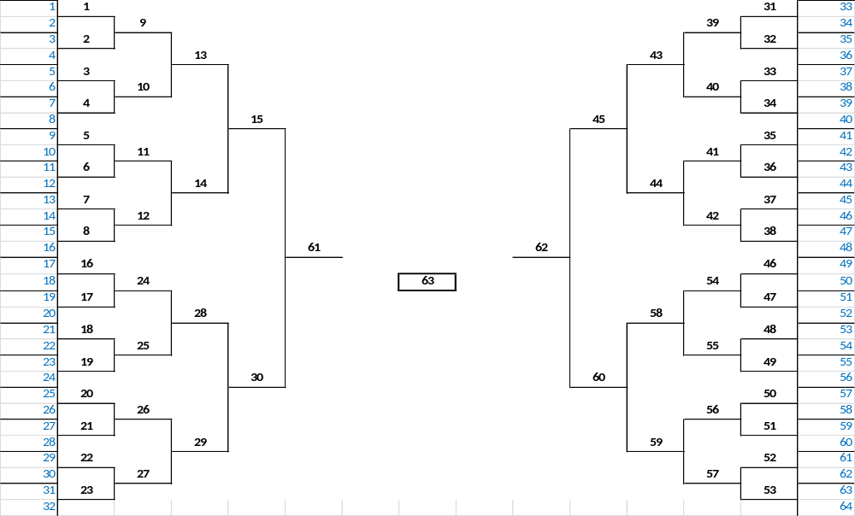

Transitions:
Transitions represent all (often more than one) all other game states one must make a choice in after making a choice in the current game to eventually fill out the entire bracket. In the March Madness Model, one always transitions with certainty to one or more game states.

Rewards:
Rewards represent the “Desirability” of choosing a given team as the winner of a given game state. “Desireability” is defined as the “Expected Relative Score” of choosing a given team in the current game state, as well as all game states preceding that the team would have had to win to reach the current game state.

Expected Relative Score

68-team tournament if the so-called play in games are included

